Artificial Intelligence in Radiology: Current Applications, Clinical Challenges, and Future Perspectives

Afshan Fareed
Department of Radiology, Khyber Medical University IHS SWAT
Email: afshanfareed077@gmail.com

Marwa Eman
Department of Radiology, Khyber Medical University IHS SWAT
Email: emanmarwa155@gmail.com

Kiran Ali
Department of Radiology, Khyber Medical University IHS SWAT
Email: ba8093696@gmail.com

Isma Rasheed
Department of Radiology, Khyber Medical University IHS SWAT
Email: abdurrasheedismakhan@gmail.com

Abstract
Author Details

Keywords: Artificial Intelligence; Radiology; Medical Imaging; Machine Learning; Deep Learning; Convolutional Neural Networks; Transformers; Foundation Models; Generative Ai; Multimodal AI

Received on 15 Mar 2026
Accepted on 20 Mar 2026
Published on 31 Mar 2026
Corresponding E-mail & Author*:

Afshan Fareed
Department of Radiology, Khyber Medical University IHS SWAT
Email: afshanfareed077@gmail.com

Artificial intelligence (AI) is rapidly transforming radiology by supporting medical image analysis, diagnosis, quantitative assessment, workflow optimization, and reporting. Advances from conventional computer-aided diagnosis to machine learning, deep learning, transformers, foundation models, generative AI, and multimodal systems have expanded AI applications across CT, MRI, chest radiography, mammography, ultrasound, PET, and SPECT. However, clinical implementation remains challenging because of dataset bias, limited generalizability, false predictions, explainability, automation bias, privacy, cybersecurity, and regulatory concerns. Generative and multimodal AI offer new opportunities for integrating imaging with clinical information but introduce additional risks, including hallucination and incorrect reasoning. This narrative review summarizes the major applications, benefits, limitations, validation requirements, workflow integration, ethical considerations, and future directions of AI in radiology. Current evidence supports a human-AI partnership in which AI enhances radiologists’ capabilities while radiologists retain clinical judgment and final decision-making responsibility.

Introduction
Radiology plays a central role in modern healthcare by providing non-invasive information about anatomy, pathology, physiology, and treatment response. The widespread use of digital radiography, computed tomography (CT), magnetic resonance imaging (MRI), ultrasound, mammography, positron emission tomography (PET), and single-photon emission computed tomography (SPECT) has produced increasingly large and complex imaging datasets. At the same time, radiologists must interpret large numbers of examinations, compare current and previous studies, perform quantitative assessments, communicate urgent findings, and generate reports. These pressures have encouraged the development of computational tools that can support selected parts of the radiology workflow.
Artificial intelligence refers broadly to computational methods capable of performing tasks associated with human cognitive functions, including pattern recognition, prediction, classification, and decision support. In radiology, early computer-aided diagnosis systems relied on predefined rules and manually engineered image features. Machine-learning methods subsequently allowed statistical models to learn relationships between imaging features and clinical outcomes. Deep learning represented a major change because neural networks could learn hierarchical image representations directly from data rather than depending entirely on manually designed features [1-3]. Convolutional neural networks (CNNs) became particularly influential in image classification, detection, and segmentation, while architectures such as U-Net became widely used for biomedical image segmentation [4].
The field has continued to evolve. Transformer architectures can model relationships across image regions and have been investigated for classification, segmentation, reconstruction, and multimodal tasks. Foundation models extend this concept by learning generalized representations from large datasets that can potentially be adapted to multiple downstream tasks [5]. Generative AI and large language models have also expanded research beyond image-only analysis toward report generation, summarization, and interaction with clinical information.
The clinical literature demonstrates substantial potential; however, translating research into routine practice remains challenging. Many models are developed retrospectively on selected datasets and may perform differently when applied to another hospital, population, scanner, or acquisition protocol. Bias, limited external validation, privacy, cybersecurity, automation bias and workflow incompatibility can therefore limit clinical utility [10-13,28]. The purpose of this narrative review is to summarize major advances in AI-assisted radiology while emphasizing not only technical applications but also clinical validation, workflow integration, explainability, fairness, governance, generative AI, multimodal systems, and future directions.

LITERATURE SEARCH STRATEGY
This article was designed as a narrative review of AI in radiology and medical image interpretation. Literature was considered from PubMed/MEDLINE, Scopus, Web of Science, and Google Scholar. Search concepts included artificial intelligence, machine learning, deep learning, radiology, medical imaging, computer-aided diagnosis, convolutional neural networks, transformers, foundation models, radiomics, explainable AI, CT, MRI, X-ray, mammography, ultrasound, and radiology report generation. Priority was given to peer-reviewed reviews, systematic reviews, methodological studies, clinical validation studies, major imaging-AI investigations, and guidance from professional or regulatory organizations.
The literature was organized thematically according to technological development, imaging modality, diagnostic application, workflow, validation, explainability, ethics, and future development. Because this is a narrative review, it does not claim to provide a systematic review or meta-analysis and does not present pooled effect estimates. This limitation should be made explicit because the selection of literature is not governed by a formal systematic-review protocol.

EVOLUTION OF ARTIFICIAL INTELLIGENCE IN RADIOLOGY

Conventional computer-aided diagnosis
Early computer-aided systems generally used image preprocessing, manually engineered features, classification rules, and presentation of a computer-generated result to the radiologist. Features could include intensity, texture, shape, edges, and anatomical relationships. Such systems demonstrated the feasibility of computational assistance but depended strongly on feature engineering and predefined assumptions.

Machine learning and radiomics
Machine learning introduced algorithms capable of identifying statistical patterns from data. Support vector machines, decision trees, random forests, logistic regression, and boosting methods were used in different medical-imaging applications. Radiomics provided a related pathway by converting images into quantitative descriptors of intensity, texture, shape, heterogeneity, and spatial relationships. These features could then be used for classification, prognosis, or prediction. However, radiomics can be sensitive to acquisition and reconstruction parameters, making standardization and reproducibility important.

Deep learning
Deep learning enabled models to learn hierarchical representations from imaging data [1-3]. CNNs became especially important because convolutional operations can identify spatial patterns and combine local information into increasingly complex representations. Applications include classification, lesion detection, organ and tumor segmentation, reconstruction, synthesis, quantitative analysis, and prognostic prediction. The main advantages of deep learning are its capacity for representation learning and strong performance on many image-analysis tasks; important limitations include dependence on large datasets, computational requirements, and vulnerability to dataset shift.

Transformer architectures
Transformers were initially developed for sequence modeling but have increasingly been adapted to medical imaging. Vision transformers and hybrid CNN-transformer systems can capture long-range relationships between image regions. Their potential is particularly relevant to complex imaging and multimodal tasks. However, transformer models can require substantial computational resources and large training datasets, and clinical performance still depends on careful validation.

Foundation models
Foundation models represent a shift from single-task models toward large pretrained systems that may support multiple downstream tasks [5]. In radiology, the concept is attractive because the same underlying representation could potentially be adapted to different modalities, body regions, and clinical questions. However, foundation models introduce additional concerns about data provenance, transparency, bias, computational cost, reproducibility, hallucination in generative settings, and clinical safety.

Table 1. Evolution of AI Technologies in Radiology
AI technology | Main approach | Major applications | Key advantage | Main limitation
Conventional CAD | Rules and engineered features | Detection and diagnosis | Computational assistance | Limited adaptability
Machine Learning | Statistical learning | Classification and prediction | Learns patterns from data | Feature dependence
Radiomics | Quantitative image features | Characterization and prognosis | Extracts measurable imaging information | Sensitive to technical variation
Deep Learning/CNNs | Automatic feature learning | Detection, classification, segmentation | Strong image-analysis capability | Requires representative data
Transformers | Attention-based learning | Imaging and multimodal tasks | Captures broader context | Computational demands
Foundation Models | Large-scale pretraining | Multitask applications | Transferability and flexibility | Validation and bias challenges
Generative/Multimodal AI | Generation and information integration | Reporting and clinical decision support | Integrates broader information | Hallucination, privacy, and safety concerns

MAJOR AI TECHNIQUES FOR MEDICAL IMAGE ANALYSIS
Image classification
Classification assigns an image or region to one or more diagnostic categories. Examples include normal versus abnormal chest radiographs, benign versus malignant lesions, pneumonia classification, tumor subtype classification, and fracture detection. Classification is among the most common deep-learning applications in medical imaging.

Object detection
Object-detection systems identify and localize abnormalities. Radiological examples include pulmonary nodules, breast lesions, intracranial hemorrhage, fractures, pulmonary opacities, and polyps. Detection can direct the radiologist toward suspicious regions, although false-positive alerts may increase workload.

Image segmentation
Segmentation identifies specific anatomical or pathological structures. Applications include brain tumors, liver lesions, lung nodules, cardiac chambers, blood vessels, and organs. U-Net and related approaches have become important in biomedical segmentation [4]. Automated segmentation can support lesion-volume measurement, organ quantification, treatment-response assessment, and radiation-treatment planning.

Image reconstruction
AI can reconstruct images from incomplete, noisy, or low-dose acquisition data. Potential applications include CT noise reduction, low-dose imaging, and accelerated MRI. The clinical objective is not simply a visually pleasing image; reconstructed images must preserve diagnostically relevant information and should be evaluated for artifacts and task-specific performance.

Radiomics
Radiomics converts images into quantitative features describing tumor heterogeneity, texture, shape, intensity, and spatial distribution. These features may support diagnosis, prognosis, response assessment, and personalized medicine. However, radiomic features can vary with scanners, acquisition parameters, reconstruction methods, segmentation, and preprocessing. Standardization is therefore essential before widespread clinical use.

Generative AI
Generative AI can create or transform data and can potentially support report generation, image synthesis, data augmentation, reconstruction, report summarization, and clinical documentation. Recent systematic work has described rapid growth in deep-learning and large-language-model approaches to automated radiology report generation [15]. The major safety issue is that a generated output can appear fluent and plausible while containing incorrect information. In clinical reporting, radiologist verification therefore remains essential.

APPLICATIONS ACROSS RADIOLOGICAL MODALITIES
Chest radiography
Chest radiography is one of the most extensively investigated areas of radiological AI because of its high volume and broad diagnostic use. Applications include pneumonia, pneumothorax, pulmonary nodules, cardiomegaly, pleural effusion, tuberculosis screening, and interstitial lung disease assessment. Deep-learning systems can perform classification, localization, segmentation, and triage [6]. However, performance may vary with patient demographics, image quality, scanner characteristics, and disease prevalence. AI triage may be particularly useful where rapid identification of potentially urgent examinations is clinically important.

Computed tomography
CT provides high-resolution anatomical information and is used extensively in emergency medicine, oncology, pulmonary medicine, and cardiovascular imaging. AI applications include pulmonary-nodule detection, lung-cancer screening, intracranial hemorrhage detection, stroke assessment, liver-lesion detection, tumor and organ segmentation, bone analysis, and reconstruction. A landmark study demonstrated an end-to-end three-dimensional deep-learning approach for lung-cancer screening using low-dose CT [7]. CT therefore represents one of the more mature areas of radiological AI research. Nevertheless, performance should be evaluated across different scanners, protocols, populations, and clinical environments.

Magnetic resonance imaging
MRI is widely used for neurological, musculoskeletal, cardiovascular, and oncological imaging. AI can support reconstruction, denoising, segmentation, tumor detection, stroke assessment, prostate imaging, cardiac imaging, and quantitative analysis. Accelerated reconstruction is especially attractive because shorter acquisition times could improve patient comfort and scanner efficiency. The key clinical requirement is that acceleration must not remove or distort diagnostically relevant information.

Mammography
AI has been extensively studied in breast imaging for cancer detection, screening, lesion characterization, risk prediction, breast-density assessment, and workflow prioritization. An international evaluation demonstrated the potential of AI-assisted mammographic interpretation [8]. A dedicated review of breast X-ray imaging also described potential applications in risk estimation, triage, detection, diagnosis, and reduction of reading time, while emphasizing that much of the evidence remained retrospective and that prospective evaluation is needed [9]. These observations illustrate a broader principle: promising performance in retrospective datasets does not by itself establish real-world clinical effectiveness.

Ultrasound
Ultrasound is strongly influenced by operator technique and acquisition quality. AI applications include thyroid-nodule classification, breast-lesion assessment, fetal imaging, liver assessment, cardiac ultrasound, and automated measurements. AI may improve standardization, particularly for quantitative tasks. However, variability in acquisition remains an important challenge and should be considered during model development and validation.

PET and SPECT
AI is increasingly investigated in nuclear medicine for lesion detection, reconstruction, segmentation, quantitative assessment, and treatment-response monitoring. The combination of functional and anatomical information creates opportunities for multimodal analysis. However, datasets can be relatively specialized, and models require validation across different tracers, scanners, protocols, and clinical populations.

AI-ASSISTED DIAGNOSIS AND CLINICAL DECISION SUPPORT
AI can provide radiologists with suspicious regions, probability scores, measurements, and structured outputs. A simplified workflow is: image acquisition, preprocessing, AI inference, detection/segmentation, classification, quantitative analysis → radiologist review → clinical decision. For example, an AI system may identify pulmonary nodules on CT and estimate their size or probability of malignancy. The radiologist must then integrate the output with clinical history, previous imaging, laboratory data, symptoms, risk factors, and other findings.
This model highlights an important distinction between technical performance and clinical usefulness. A model can have a high area under the receiver operating characteristic curve while adding little value if its output is difficult to access, poorly calibrated, redundant, or associated with excessive false-positive alerts.Therefore, the clinical usefulness of AI should be evaluated not only by diagnostic performance but also by its effect on radiologist performance, workflow efficiency, decision-making, safety, and patient outcomes.

AI AND RADIOLOGY WORKFLOW
The potential role of AI extends beyond image interpretation. AI may assist with examination prioritization, protocol selection, image acquisition, reconstruction, detection, quantitative measurement, comparison with previous examinations, report generation, follow-up assessment, and quality assurance. Workflow integration is a major determinant of clinical value. An accurate algorithm can have limited practical usefulness if its results are difficult to retrieve, poorly timed, or generate excessive alerts.
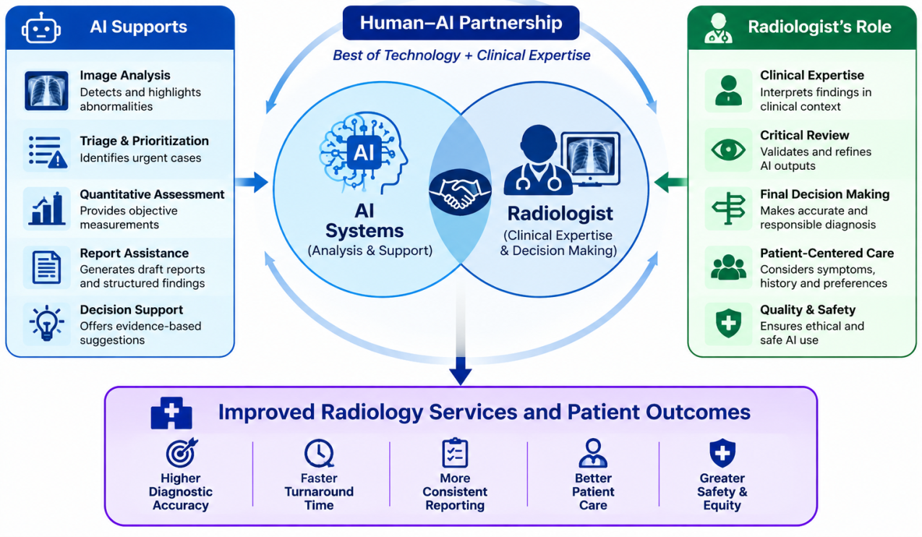
Implementation frameworks emphasize governance, stakeholder involvement, local performance assessment, workflow fit, and post-deployment monitoring [24-26]. Successful adoption therefore requires collaboration among radiologists, technologists, information-technology teams, administrators, data scientists, vendors, and other stakeholders. The objective should be to solve a defined clinical problem rather than to introduce AI simply because a technology is available.The clinical value of workflow-integrated AI should therefore be assessed not only by diagnostic performance but also by its effects on reporting time, radiologist workload, workflow efficiency, communication, and patient safety
Figure 1. Human-AI collaboration model in radiology, demonstrating AI-assisted triage, image analysis, quantitative assessment, and reporting with final clinical oversight by the radiologist.

CLINICAL BENEFITS

8.1 Detection and triage
AI may help identify selected abnormalities and prioritize examinations that appear urgent. The value of such systems depends on sensitivity, specificity, prevalence, alert burden, and the consequences of missed or incorrectly prioritized examinations.

Workflow efficiency
Automation may reduce repetitive measurements and assist with prioritization or preliminary analysis. However, efficiency should be measured in real clinical workflows rather than inferred solely from algorithm speed.

Quantitative assessment
AI can automatically estimate lesion diameter, tumor volume, organ volume, imaging biomarkers, and disease burden. Standardized measurements may reduce some observer variability and facilitate longitudinal assessment.

Reconstruction and acquisition
AI-based reconstruction may support lower-dose CT or faster MRI acquisition. These applications must be evaluated for diagnostic fidelity rather than image appearance alone.

Personalized imaging
Combining imaging features with clinical information may eventually support individualized risk estimation and protocol selection. Such applications require careful prospective validation.

LIMITATIONS AND CHALLENGES
Dataset bias
AI systems learn from training data. If the data do not represent the intended population, performance may differ across demographic or clinical groups. Sources of bias include demographic imbalance, geographic imbalance, disease prevalence, scanner differences, image quality, labeling errors, and institutional practices [10,11]. Objective frameworks for studying bias have shown that controlled bias scenarios can produce subgroup performance disparities and that bias mitigation requires explicit evaluation rather than assumptions of fairness [11].

Generalizability and dataset shift
An algorithm developed at one institution may not perform identically elsewhere. Differences in equipment, protocols, demographics, disease prevalence, preprocessing, and clinical practice can affect performance. External validation should therefore be considered an essential step before widespread deployment.

False-positive and false-negative predictions
False-positive outputs may increase unnecessary examinations, callbacks, and workload, while false-negative outputs may contribute to missed disease. Evaluation should therefore include sensitivity, specificity, predictive values, ROC-AUC, calibration, and clinically meaningful outcomes rather than accuracy alone.

Explainability
Deep-learning systems may be difficult to interpret. Saliency maps, Grad-CAM, feature attribution, attention visualization, and case-based explanations can provide useful information, but a visually convincing explanation does not necessarily demonstrate the true causal reasoning of a model [17,18]. Explainability should therefore be assessed for clinical usefulness and reliability.

Automation bias
Automation bias occurs when clinicians place excessive confidence in automated outputs. A false-normal AI result may contribute to an abnormality being overlooked, while a false-positive result may attract disproportionate attention. Human oversight and appropriate interface design are therefore essential.

Privacy and data security
Medical images and linked clinical data contain sensitive information. AI development requires appropriate de-identification, access control, data protection, cybersecurity, and governance. Multimodal systems increase the amount and diversity of information that must be protected.

Cybersecurity
AI systems integrated into clinical infrastructure may be exposed to technical attacks, including adversarial manipulation. Security should therefore be considered during development, procurement, integration, and monitoring rather than treated as an issue only after deployment [16].
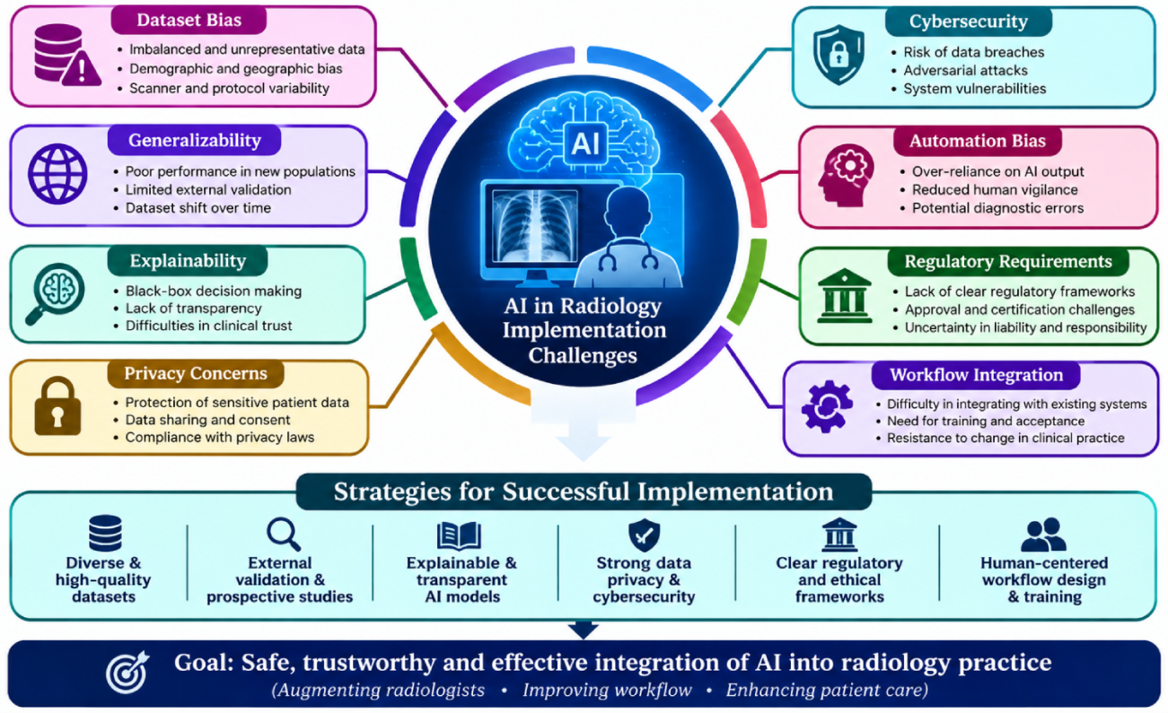
Figure 2. Major challenges associated with clinical implementation of AI in radiology, including dataset bias, generalizability, explain ability, privacy, cyber security, automation bias, regulatory requirements, and workflow integration.

EXPLAINABLE AI, FAIRNESS, AND EQUITY
Explainable AI aims to make model predictions more understandable to clinicians. In radiology, explanations may highlight image regions or features associated with a prediction. However, explain ability should not be confused with proof of correctness. A model can produce an attractive heat map and still rely on an inappropriate feature. Explanations should therefore be evaluated alongside model performance and clinical behavior.
Fairness should be considered throughout the AI lifecycle: data collection, labeling, development, validation, deployment, and monitoring. Strategies include diverse datasets, subgroup analysis, external validation, representative patient recruitment, fairness evaluation, and continuous monitoring [10,11]. The goal is not merely high average performance but reliable performance for clinically important subgroups.

CLINICAL VALIDATION AND REPORTING STANDARDS
High performance on retrospective data does not necessarily establish clinical effectiveness [14]. A robust development pathway can be viewed as training → internal validation → external validation → prospective evaluation → implementation → continuous monitoring. Clinical evaluation should examine diagnostic performance, radiologist performance, reading time, false-positive workload, workflow changes, user acceptance, safety, and patient outcomes.
Reporting standards are important for reproducibility. CLAIM was developed to improve reporting of AI studies in medical imaging, and the 2024 update reflects methodological developments and emphasizes complete reporting of study design, datasets, reference standards, model development, evaluation, and limitations [19,20]. MI-CLAIM provides complementary guidance for reporting clinical AI models [23].
The use of standardized reporting does not guarantee a high-quality model, but it makes study methods easier to evaluate and reproduce. Important elements include dataset source, patient selection, inclusion and exclusion criteria, reference standard, training procedure, validation procedure, architecture, performance metrics, external validation, limitations, and reproducibility information.

ETHICAL AND REGULATORY CONSIDERATIONS
AI in radiology raises ethical questions concerning autonomy, privacy, fairness, accountability, safety, and responsibility. WHO guidance emphasizes human autonomy, safety, transparency, accountability, equity, and sustainable development in health AI [21]. Guidance concerning large multimodal models adds considerations related to the complex generation and integration of information [22].
Regulatory oversight is also important because AI-enabled medical devices can change after deployment and may operate in variable clinical environments. Procurement and implementation should therefore consider intended use, evidence of effectiveness, local performance, cyber security, update procedures, and post-deployment monitoring. Professional societies have emphasized the need to distinguish potentially useful products from tools that may be unsafe or clinically unhelpful [26].
Implementation should also have clear responsibility structures. Governance frameworks have proposed defined processes for selecting tools, implementing them, monitoring performance, and maintaining them after deployment [24]. Practical implementation experience further indicates that clinical, technical, and financial stakeholders should collaborate and that post-deployment surveillance requires dedicated infrastructure [25].

GENERATIVE AND MULTIMODAL AI
Generative AI has expanded the possible role of AI from image analysis toward text generation, summarization, documentation, and interaction with clinical information. Potential radiology applications include automated report drafting, structured reporting, prior-study comparison, report summarization, and patient-friendly explanations [15]. The principal concern is hallucination: an AI system may generate a fluent statement that is unsupported by the images or clinical record. A safe workflow therefore remains AI-generated draft -radiologist verification - final report.
Multimodal AI aims to integrate medical images with radiology reports, clinical history, laboratory data, pathology, and other biomedical information. This may address an important limitation of image-only systems: radiological interpretation rarely occurs without clinical context. Recent work on practical integration has emphasized that incorporating prior imaging and clinical background may be important for effective AI deployment [27].
However, multimodal systems also introduce additional risks, including hallucinated information, incorrect reasoning, bias, privacy concerns, data leakage, and reduced transparency. Their broader information access does not automatically make them clinically reliable. Rigorous evaluation should compare multimodal systems with image-only approaches and examine whether additional information improves clinically meaningful decisions.
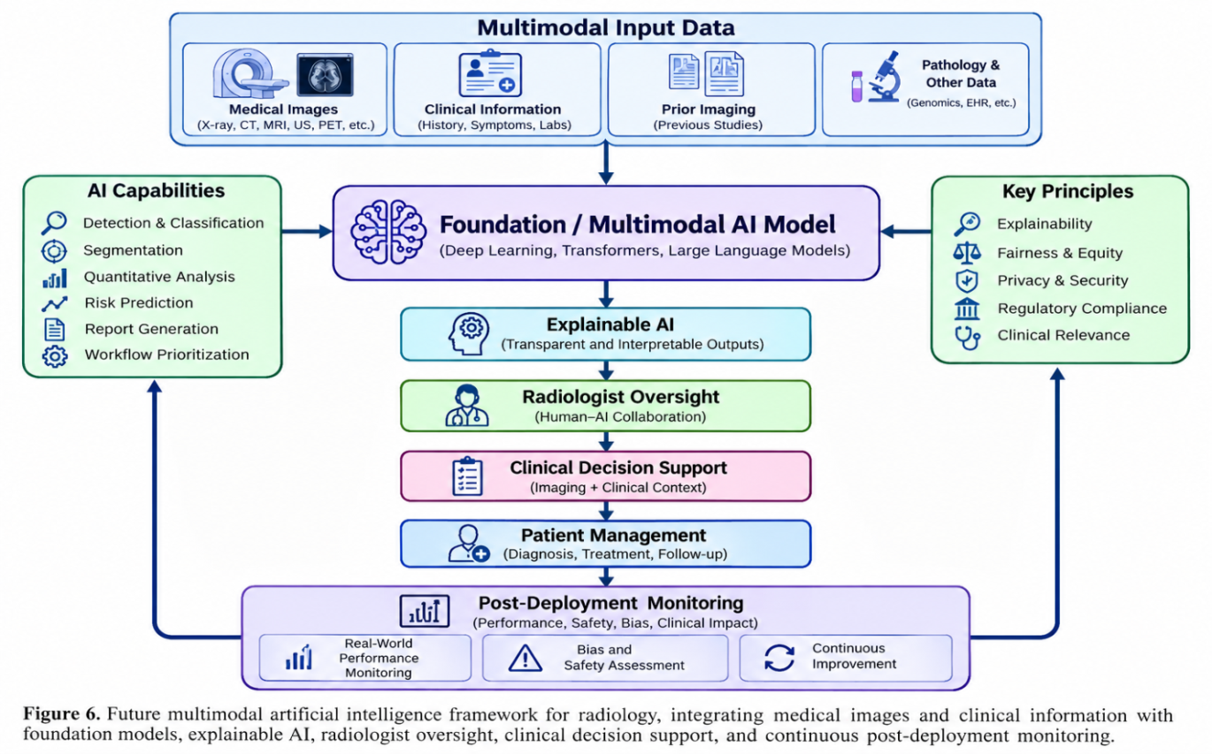
Figure 3. Future multimodal AI framework integrating medical images, clinical information, foundation models, explainable AI, radiologist oversight, clinical decision-making, and continuous post-deployment monitoring.

FUTURE PERSPECTIVES

14.1 Foundation models
Foundation models may allow a common pretrained representation to support several imaging tasks and modalities [5]. Their clinical value will depend on data quality, transferability, computational feasibility, and external validation.

Multimodal clinical reasoning
Future systems may combine images with clinical histories, laboratory data, pathology, and prior examinations. Such systems may provide more contextual decision support, but the added complexity requires careful assessment of hallucination, bias, and privacy.

Personalized imaging
AI may assist in selecting individualized imaging protocols based on patient characteristics and clinical questions. Such applications should be evaluated for safety, reproducibility, and whether they improve patient outcomes.

Continuous learning and monitoring
Clinical populations, scanners, protocols, and disease prevalence change over time. AI performance may therefore drift. Post-deployment monitoring and predefined procedures for model updates are essential [24,26].

Agentic AI
Emerging agentic systems may coordinate several computational tasks across the radiology workflow. Their potential autonomy introduces additional questions about safety, accountability, cybersecurity, and human oversight. These systems should be regarded as an emerging research direction rather than established routine clinical practice.

DISCUSSION
AI in radiology has progressed from conventional computer-aided diagnosis to deep learning, transformers, foundation models, generative AI, and multimodal systems. This progression has expanded the range of tasks that can be automated or assisted. The strongest evidence in the reviewed literature is concentrated in specific task-oriented applications such as classification, lesion detection, segmentation, reconstruction, and workflow support, with chest radiography, CT, and mammography among the most extensively investigated areas the most important issue for clinical translation is that algorithmic performance is not equivalent to clinical effectiveness. A model may perform well on a retrospective dataset yet fail when exposed to a different population or imaging environment. Consequently, external validation, prospective evaluation, workflow assessment, and continuous monitoring are central to safe implementation. This principle is consistent with published governance and implementation frameworks bias should be treated as a clinical and ethical problem rather than solely a technical problem. Representative datasets and subgroup evaluation are necessary, but fairness also requires monitoring after deployment. Explain ability can help clinicians understand model behavior, but current explanation methods do not eliminate uncertainty about why a model fails generative and multimodal AI may provide substantial new capabilities, particularly for reporting and contextual decision support. However, their ability to produce convincing language creates a new safety challenge: incorrect outputs can appear credible. Therefore, human verification should remain central until robust evidence supports more autonomous use.
The future of radiology should consequently be viewed as a human-AI partnership. AI is well suited to repetitive computational operations, quantitative measurements, and prioritization, while radiologists integrate imaging with patient context, evaluate uncertainty, communicate with other clinicians and patients, and take responsibility for final clinical decisions. Successful implementation will depend less on technological novelty than on evidence, workflow design, governance, safety, and measurable clinical benefit.

LIMITATIONS OF THE REVIEW
This review has several limitations. First, it is a narrative rather than systematic review and therefore does not provide a formal PRISMA-based quantitative synthesis. Second, AI in medical imaging is evolving rapidly, so newly published models and clinical studies may change the evidence landscape. Third, differences in study design, datasets, imaging modalities, reference standards, and performance metrics make direct comparison between systems difficult. Fourth, much of the literature remains retrospective, whereas evidence from real-world implementation is less extensive than evidence from technical development. Finally, ethical and regulatory frameworks continue to evolve as AI becomes more integrated into healthcare.

CONCLUSION
Artificial intelligence is becoming an important component of modern radiology. Progress from machine learning and deep learning to CNNs, transformers, foundation models, generative AI, and multimodal systems has expanded opportunities for medical-image interpretation, reconstruction, segmentation, quantitative analysis, triage, workflow support, and reporting. Applications have been investigated across X-ray, CT, MRI, mammography, ultrasound, PET, and SPECT.
The major challenge is no longer simply whether an algorithm can achieve high performance on a dataset. The more important question is whether the system remains accurate, fair, safe, interpretable, secure, and clinically useful in real-world practice. Dataset bias, limited generalizability, false-positive and false-negative predictions, automation bias, privacy, cybersecurity, workflow integration, and regulatory requirements must therefore be addressed throughout the AI lifecycle.
Future research should prioritize representative datasets, external validation, prospective clinical studies, standardized reporting, transparent development, human-centered workflow integration, and continuous post-deployment monitoring. Foundation and multimodal models may broaden the scope of radiological AI, but their increasing complexity makes rigorous evaluation even more important. Overall, current evidence supports a human-AI partnership in which AI augments radiological practice while radiologists retain responsibility for contextual interpretation, uncertainty assessment, communication, and final clinical decision-making.

References
1.Litjens G, Kooi T, Bejnordi BE, Setio AAA, Ciompi F, Ghafoorian M, et al. A survey on deep learning in medical image analysis. Med Image Anal. 2017;42:60-88.
2.LeCun Y, Bengio Y, Hinton G. Deep learning. Nature. 2015;521:436-444.
3.Lundervold AS, Lundervold A. An overview of deep learning in medical imaging focusing on MRI. Z Med Phys. 2019;29:102–127.
4.Isensee F, Jaeger PF, Kohl SAA, Petersen J, Maier-Hein KH. nnU-Net: a self-configuring method for deep learning-based biomedical image segmentation. Nat Methods. 2021;18:203–211.
5.Bian Y, Li J, Ye C, Jia X, Yang Q. Artificial intelligence in medical imaging: from task-specific models to large-scale foundation models. Chin Med J (Engl). 2025;138:651–663.
6.Çallı E, Sogancioglu E, van Ginneken B, van Leeuwen KG, Murphy K. Deep learning for chest X-ray analysis: A survey. Med Image Anal. 2021;72:102125.
7.Ardila D, Kiraly AP, Bharadwaj S, Choi B, Reicher JJ, Peng L, et al. End-to-end lung cancer screening with three-dimensional deep learning on low-dose chest CT. Nat Med. 2019;25:954–961.
8.McKinney SM, Sieniek M, Godbole V, Godwin J, Antropova N, Ashrafian H, et al. International evaluation of an AI system for breast cancer screening. Nature. 2020;577:89–94.
9.Vedantham S, Shazeeb MS, Chiang A, Vijayaraghavan GR. Artificial intelligence in breast X-ray imaging. Semin Ultrasound CT MR. 2023;44(1):2–7.
10.Koçak B, et al. Bias in artificial intelligence for medical imaging: fundamentals, detection, avoidance, mitigation, challenges, ethics, and prospects. Diagn Interv Radiol. 2025;31:75–88.
11.Stanley EAM, Souza R, Winder AJ, Gulve V, Amador K, Wilms M, Forkert ND. Towards objective and systematic evaluation of bias in artificial intelligence for medical imaging. J Am Med Inform Assoc. 2024;31(11):2613–2621.
12.Recht MP, Dewey M, Dreyer K, Langlotz C, Niessen W, Prainsack B, Smith JJ. Integrating artificial intelligence into the clinical practice of radiology: challenges and recommendations. Eur Radiol. 2020;30(6):3576–3584.
13.Liew C. The future of radiology augmented with Artificial Intelligence: a strategy for success. Eur J Radiol. 2018;102:152–156.
14.Jacobson FL, Krupinski EA. Clinical validation is the key to adopting AI in clinical practice. Radiol Artif Intell. 2021;3(4):e210104.
15.Izhar A, Idris N, Japar N. Medical radiology report generation: a systematic review of current deep learning methods, trends, and future directions. Artif Intell Med. 2025;168:103220.
16.Dietrich N, Gong B, Patlas MN. Adversarial artificial intelligence in radiology: attacks, defenses, and future considerations. Diagn Interv Imaging. 2025.
17.Borys K, Schmitt YA, Nauta M, Seifert C, Krämer N, Friedrich CM, et al. Explainable AI in medical imaging: an overview for clinical practitioners. Eur J Radiol. 2023;162:110786.
18.Champendal M, Müller H, Prior JO, Sá Dos Reis C. A scoping review of interpretability and explainability concerning artificial intelligence methods in medical imaging. Eur J Radiol. 2023;169:111159.
19.Mongan J, Moy L, Kahn CE Jr. Checklist for Artificial Intelligence in Medical Imaging (CLAIM): a guide for authors and reviewers. Radiol Artif Intell. 2020;2:e200029.
20.Tejani AS, Klontzas ME, Gatti AA, Mongan JT, Moy L, Park SH, Kahn CE Jr; CLAIM 2024 Update Panel. Checklist for Artificial Intelligence in Medical Imaging (CLAIM): 2024 Update. Radiol Artif Intell. 2024;6(4):e240300.
21.World Health Organization. Ethics and Governance of Artificial Intelligence for Health: WHO Guidance. Geneva: World Health Organization; 2021.
22.World Health Organization. Ethics and Governance of Artificial Intelligence for Health: Guidance on Large Multi-Modal Models. Geneva: World Health Organization; 2025.
23.Norgeot B, Quer G, Beaulieu-Jones BK, et al. Minimum information about clinical artificial intelligence modeling: the MI-CLAIM checklist. Nat Med. 2020;26:1320-1324.
24.Daye D, Wiggins WF, Lungren MP, Alkasab T, Kottler N, Allen B, et al. Implementation of clinical artificial intelligence in radiology: who decides and how? Radiology. 2022;305(3):555–563.
25.Bizzo BC, Dasegowda G, Bridge C, Miller B, Hillis JM, Kalra MK, et al. Addressing the challenges of implementing artificial intelligence tools in clinical practice: principles from experience. J Am Coll Radiol. 2023;20(3):352–360.
26.Brady AP, Allen B, Chong J, Kotter E, Kottler N, Mongan J, et al. Developing, purchasing, implementing and monitoring AI tools in radiology: practical considerations. A multi-society statement from the ACR, CAR, ESR, RANZCR & RSNA. Radiol Artif Intell. 2024;6(1):e230513.
27.Katal S, York B, Gholamrezanezhad A. AI in radiology: from promise to practice-a guide to effective integration. Eur J Radiol. 2024;181:111798.
28.Flory MN, Napel S, Tsai EB. Artificial intelligence in radiology: opportunities and challenges. Semin Ultrasound CT MR. 2024;45(2):152–160

